THE MUNCHING QUEEN
Soon Domain: themunchingqueen.com

About Us
Foto: Product with kids
Hi Everyone
We are a group of parents & snack enthusiasts from Surabaya, Indonesia. Growing up, we witnessed how kerupuk has been a cornerstone of Indonesian’s dining just like sambal.
We launched Kroepoek Waroeng in 2016 at a food expo in Dubai, UAE and looking at the enthusiasm of the international customers towards our Indonesian crackers has motivated us to Introduce the Indonesian food heritage by creating deliciously flavoured, ready to eat kerupuk through our brand, The Munching Queen.
During the pandemic, we were looking for more options of locally made, kids friendly snacks without any of the nasty ingredients for our then 3 year old boy but could not find many options that he likes.
Having lived in Melbourne has made us more cautious about ingredients especially for our little ones. Thus we experimented with countless natural ingredient to create a more affordable, healthier options snacks that kids will love from kerupuk without compromising its quality and that’s when fish & cheese series was born out of our kitchen.
We believe that quality is key and that healthier options snack can taste as good. We hope your little ones love them as much as we do.
Happy Munching!

Certifications
Foto: Product with kids
We believe it is important t trust your manufacturer and to do things the right way not the easy way.
- Our main facility is ISO 22000:2005 certified
- HACCP certified : An International standard and systematic preventive approach to food safety from biological, chemical, and physical hazards in production processes
- The Packaging we use is supplied by HACCP certified manufacturer and the bucket is also food grade certified
- Regular QC by our skilled personnel as well as third party surveyor & internationally certified laboratory
- BPOM Certified
- Halal Certified

Contact Us

CV. TRINUSA JAYA ABADI
THE MUNCHING QUEEN
Alamat: ________
Email: trinusa.food@gmail.com
Telp: +62 838 9803 3439
Instagram: @themunchingqueen

We’d love to hear from you and your feedback is important to us. Please do not hesitate to contact us regarding any collaboration, feedback, and any inquiries! Drop us a line below and we’ll do our best to get back to you within one business day.
- Name
- Email
- Message

Our Products

Fish and Cheese
No Flavor Enhancer | No Artificial Color | No Presevatives | No Artificial Sweetener

Fish and Cheese: Original
Fish and Cheese series was initially home-made for our kids.
We wanted to create a healthier option snacks with safe, crunchy texture that kids will love at the first munch.
30gr | 85gr | 10gr
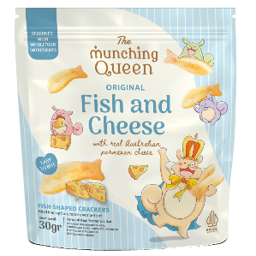 | 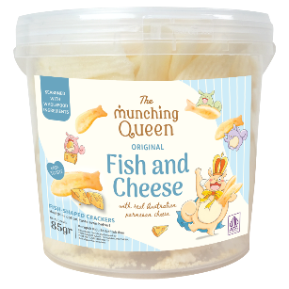 | 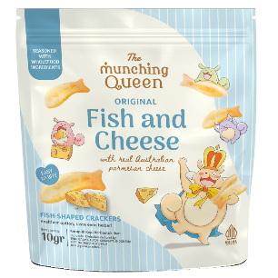
We experimented with real, fine quality ingredients in our kitchen to achieve delicious flavors without compromising it’s quality. After several trial & errors, having our family and close friends tasted them, we have finally found the flavors we are looking for and that’s how the fish & cheese was born. We believe in doing things the right way & healthier option snacks can taste as good.

Fish and Cheese: Truffle
Fish and Cheese series was initially home-made for our kids.
We wanted to create a healthier option snacks with safe, crunchy texture that kids will love at the first munch.
30gr | 85gr | 10gr
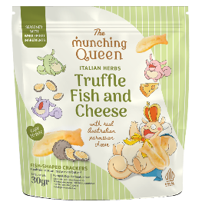 | 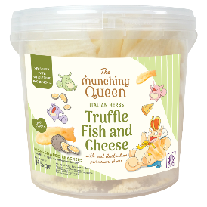 | 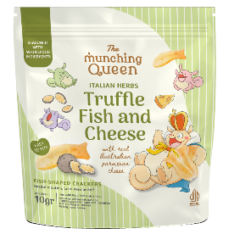
We experimented with real fine quality ingredients in our kitchen to achieve delicious flavors without compromising it’s quality. After several trial & errors, having our family and close friends tasted them, we have finally found the flavors we are looking for and that’s how the fish & cheese was born. Besides cook from the heart, one of the golden rules of Italian cooking is that less is more. Keeping it simple allows the fresh & seasonal ingredients to do the talking. We believe in doing things the right way & that healthier option snacks can taste as good.

Fish and Cheese: Korean Garlic Chicken
Fish and Cheese series was initially home-made for our kids.
We wanted to create a healthier option snacks with safe, crunchy texture that kids will love at the first munch.
30gr | 85gr | 10gr
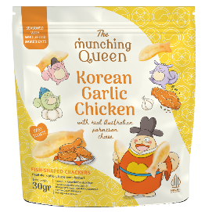 | 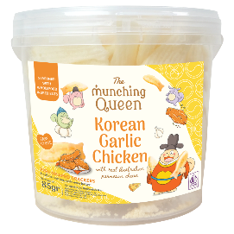 | 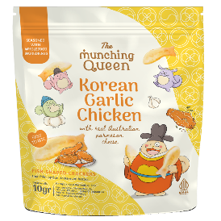
We experimented with real fine quality ingredients in our kitchen to achieve delicious flavors without compromising it’s quality. After several trial & errors, having our family and close friends tasted them, we have finally found the flavors we are looking for and
that’s how the fish & cheese was born.
Inspired by the vibrant fried chicken scene in Seoul, we developed a kids friendly Korean Garlic Chicken flavor as our new addiction to the fish and cheese family. Crafted with real chicken stocks powder, onion, garlic, cheese and sprinkle of dried green onion and sesame seeds creating a notable harmony of flavours kids will love at the first munch.

Fish and Cheese: Pizza Margherita
Fish and Cheese series was initially home-made for our kids.
We wanted to create a healthier option snacks with safe, crunchy texture that kids will love at the first munch.
30gr | 85gr | 10gr
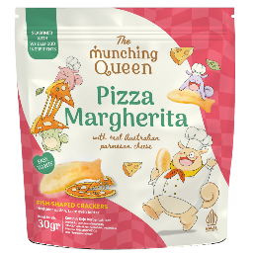 | 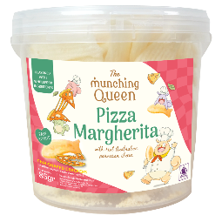 | 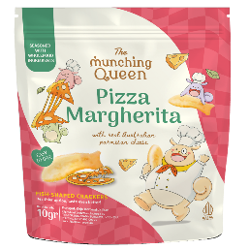
We experimented with real, fine quality ingredients in our kitchen to achieve delicious flavours without compromising it’s quality. Having our family & close friends tasted them, we finally found the flavours we are looking for.
The magic of pizza is its versatility making it universally beloved. We believe in doing things the right way & that every batch is fried using fresh vegetable oil. It is then lightly seasoned with tomatoes, parmesan cheese, mozzarella, & fresh basil just like the simple, honest & delicious Italian pizza.

Oven Baked Pasta Chips
Gluten Free | No Preservatives | No Artificial Color | No Flavour Enhancer

Spaghetti Bolognaise
Inspired by the all-times favorite comfort food. Mac & Cheese, we created the ready to munch pasta chips series.
35gr | 70gr
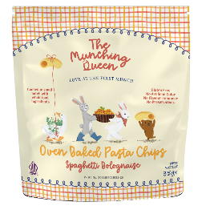 | 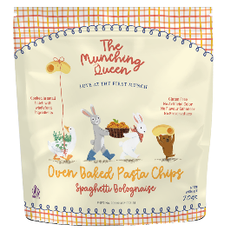
Delightfully crispy, oven-baked cheese bites made with real cheese before then seasoned with tomatoes & basil just like the simple, honest & delicious homemade bolognaise sauce we crave for.
As parents, we are very passionate & committed in creating healthier options snacks kids will love at the first munch. Buon Appetito!

Truffle
Inspired by the all-times favorite comfort food. Mac & Cheese, we created the ready to munch pasta chips series.
35gr | 70gr
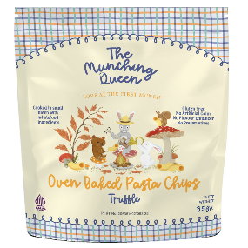 | 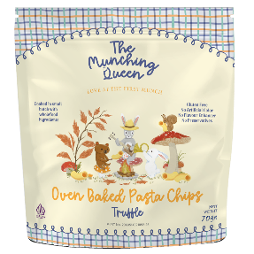
Delightfully crispy, oven-baked cheese bites made with real, delicious cheese before then lightly seasoned with salt & truffle powder. As parents, we are very passionate & committed on creating healthier options snacks kids will love at the first munch. Buon Appetito!

Crispy Brownies
Gluten Free | Free Range Eggs | Finest Belgian Chocolate | Authentic Japanese Matcha Powder

Chocolate Crispy Brownies
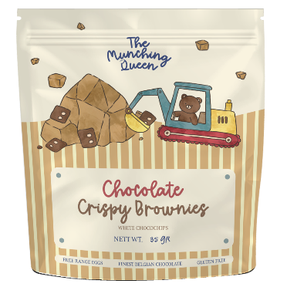
Satisfy your sweet tooth with our Crispy Brownies. Made with real Belgian chocolate, free-range egg whites with no artificial colors/flavours for your precious little ones.
Baked to golden crisp, they are the perfect mix of convenience & indulgence. Pair them with milk, share with your friends, or as a mid-day treat with your afternoon tea or coffee.
Nett: 35gr

Chocolate Crispy Brownies
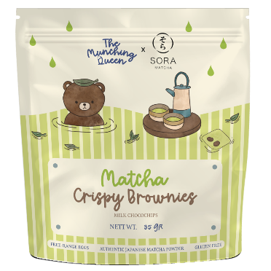
Our crispy brownies is baked into perfection with authentic Japanese matcha, free-range whites & the finest Belgian Choco chips with no artificial colors/flavours.
Matcha is known for its antioxidants & naturally calming energy. Pair them with a cup of tea making it the perfect choice for mindful snacking.
Nett: 35gr

Chocolate Crispy Brownies
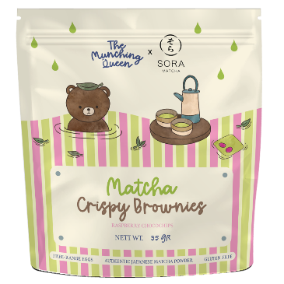
Our crispy brownies is baked into perfection with authentic Japanese matcha, free-range whites & the finest Belgian Choco chips with no artificial colors/flavours.
Matcha is known for its antioxidants & naturally calming energy. Pair them with a cup of tea making it the perfect choice for mindful snacking.
Nett: 35gr

Tempeh Chips
Gluten Free | No Artificial Sweetener | No Added Flavor Enhancer | Zero Sugar | Trans-Fat Free

Tempeh is a traditional Indonesian food made from fermented soybeans. It’s tiny but mighty nutritious & versatile. It boasts an impressive nutrient profile, taste delicious, making it a staple of Indonesian culture across generations.

We proudly support Indonesian farmers by using locally sourced,
non-GMO certified soybeans.

Original Truffle Flavor
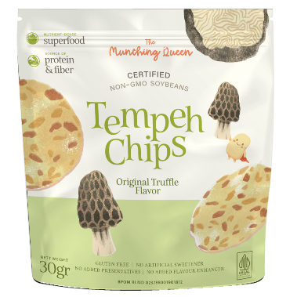
Discover the irresistible Italian-inspired flavour. Delicate slices of tempeh chips, slowly cooked & seasoned with truffle salt & a sprinkle of Italian herbs. With a satisfying crunch & rustic charm in every bite, our tempeh chips is perfect for effortless snacking. Just open, serve & savour the art of good food.
Nett: 30gr

Parmesan Chicken & Sauteed Kale Flavor
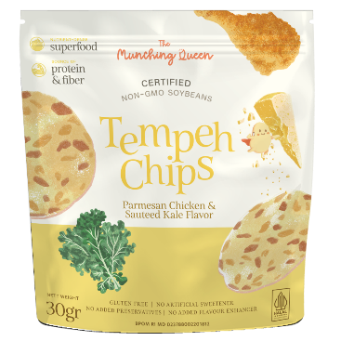
Crafted with the finest real-food ingredients, our latest flavor blends a rich garlic chicken seasoning with the subtle crisp of kale & Himalayan salt for a wholesome, hearty finish. Experience the crunch of our non-GMO soybeans combined with sweet & savory notes that add a distinct umami for a delightful snacking experience.
Nett: 30gr

Salmon Furikake Flavor
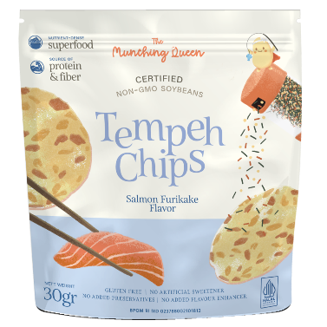
Inspired by simple but wholesome Japanese cooking, this flavour combines the bold salmon flavour, smokiness of roasted seaweed, sesame seed & garlic in perfect harmony. Experience the crunch of our non-GMO soybeans combined with sweet & savory notes that burst with flavour & umami in each bite.
Nett: 30gr

Spicy Truffle
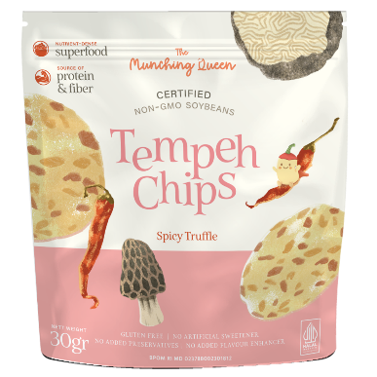
Discover the irresistible Italian-inspired flavour with a suprising twist. Delicate slices of tempeh chips, slowly cooked & seasoned with truffle salt, Italian herbs & a hint of spicy note. With a satisfying crunch and rustic charm in every bite, our tempeh chips is perfect for effortless snacking. Just open, serve & savour the art of good food.
Nett: 30gr

Chili & Lime
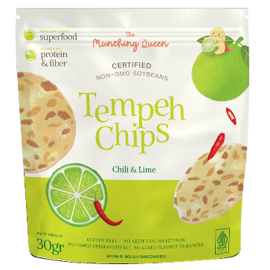
Our tempeh chips are slow-cooked for the most delectable crunch, then seasoned with a kick of chili & perfectly paired with fragrant lime. With surprising twist, grind & blends of carefully selected flavours, there’s an enticing taste journey waiting to be discovered in every bite.
Nett: 30gr

Spicy Series

Mala Xiang Guo
25gr | 85gr
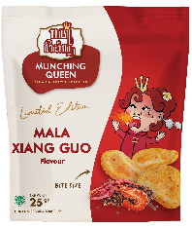 | 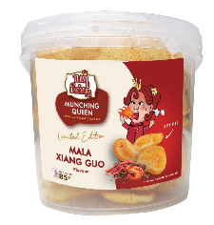
Originally from Sichuan, Mala has become increasingly popular throughout Asia and rest of the world. Our signature prawn crackers is made from fresh, real prawns from our old family recipe. It is then seasoned with our special mala spices, making it ultra scrumptious & will make you crave for more.

Sauteed Balinese Spices
30gr | 70gr
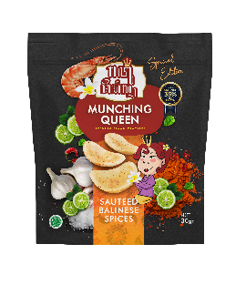 | 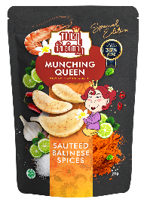
Get ready to indulge yourself in our special edition of classic yet delightful prawn crackers in Sauteed Balinese Spices.
It’s a beautiful collaboration of Indonesia’s finest prawn crackers & traditional Balinese spices. Each piece is generously seasoned with our homemade recipe of delicious Balinese spices for your remarkable experience of wonderful Indonesian food.

Cappuccino
Contains 100% real coffee beans

30gr | 60gr
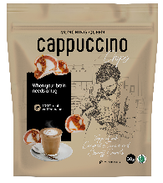 | 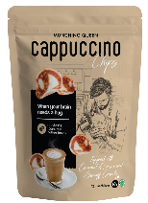
Indonesia has a very rich coffee culture and is one of the world’s most remarkable coffe plantation. Having that privilege, we wanted to create a special collaboration between the two things we love the most: chips & coffee. Coffee has become a part of tradition in people’s life, it’s no longer about the purpose of staying wide awake, but something that they enjoy.
Waking up in the morning to the smell of coffee is definitely something that we look forward to. We hope you enjoy our new creation of cappuccino chips topped with caramel sauce and sprinkled with Lotus Biscoff crumbs.

Online Marketplace

SHOPEE
Jakarta: shopee.co.id/munchingqueen
Surabaya: shopee.id/themunchingqueen

TOKOPEDIA
Jakarta: tokopedia.com/munchingqueen
Surabaya: tokopedia.com/munching-queen

